‘Managing’ Innovation
by G.S. Chandy & Nihar R. Pradhan
(about 5000 words)
Table of Contents: Pages

- Abstract and Keywords 02
- Introduction: What is Innovation? 03
• Mental Models and Innovation 03 What is a Mental Model?
-- From Mental Model to Innovation 05 - 06
• Changing our Mental Models - Closed Mind Vs. Open Mind 06 - 07
• Linear Thinking Vs. Multi-linear Thinking for Innovation 07 - 08
- How to Enable Innovation? 09
- ‘Managing’ Innovation? 10
- ‘Managing’ Innovation? – 11-12
It’s actually all about ‘Managing for Innovation’!
- A Pot-Pourri of Anecdotal Illustrations 12- 13
- Managing for Innovation is different from conventional managemen 14
- 7-‘C’ Framework 15- 18
- Making Innovation a Practice 19
- Interactive Management 20- 22
- One Page Management System (OPMS) 22- 25
- A Glimpse of Some Features & Outputs of the OPMS Process… 26
- Proposition: 27 -28
A Practical Tool to ‘Manage for Innovation’

- References 29 - 30

- About the Authors 31

- Appendices 32- 39

© Copyright by G.S. Chandy & Nihar R. Pradhan

I: Abstract:

The paper commences with a discussion of the issue of ‘Managing for Innovation’ at a very fundamental level and describes a practical means for ensuring innovation in organizations.
Innovation is a result of actualization of basic ideas that people have for adding value. People’s ideas constitute the ‘elements’ of ‘mental models’ – which are the result of the interplay of human thought with reality. The paper relates mental models to ‘innovation’ as a desired process in organizations and depicts, with illustrations, the usefulness of ‘graphical representations’ of mental models.
The ingredients of innovation are discussed in terms of the ‘environment of the human mind’. The differences between conventional, rational management and managing for innovation are brought out. A ‘7-Cs Framework’ as an appropriate basis to manage for innovation in organizations is proposed.
The ‘One Page Management System’ (OPMS), based on ‘Interactive Management’ (IM) and the Science of Generic Design, a tool that incorporates all the aforementioned desiderata and features. The paper discusses how this tool can help make innovation a regular practice within organizations.

Key Ideas, Words & Phrases

Idea Generation, Idea Structuring, Idea Engineering, Innovation, Interactive Management, Mental Model, linear vs. multi-linear, Interpretive Structural Modeling (ISM), Field Representation (FR) Method, Nominal Group Techniques (NGT), “7C” Framework, One Page Management System (OPMS)

II: Introduction: What is innovation?

“Ideas shape the course of history,” John Maynard Keynes

Innovation is the process of generating and implementing ideas so as to create wealth from under-utilized or unutilized resources through exploration and exploitation of the potential creativity of the individual/group mind. Innovations may arise in several ways:
- from new situations confronted by humans, and/or
- from new knowledge generated about existing situations, and/or
- from available knowledge being put together in new and imaginative ways (generally not predicated in the original) to generate new knowledge or to create novel products and processes.

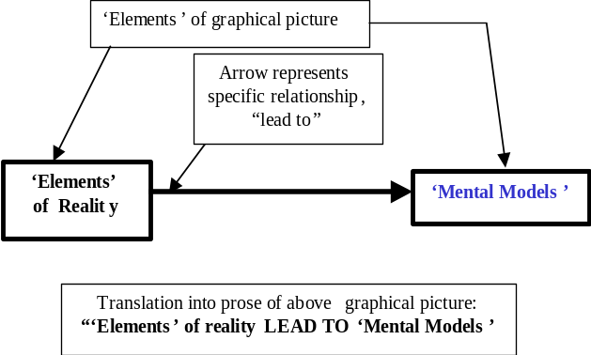
Broadly, innovation is the result of the purposeful and creative exercise of the human imagination. It is the outcome of some structured synthesis of intuitions, insights and inspirations. Innovation may often come about by accident – but even so it comes about only when a ‘prepared mind’ sees and understands the potential innovation when the idea for it strikes.
Illustration: A graphical picture about ‘Mental Models’

Mental models and innovation:

-- What is a mental model?

Our minds automatically form some kind of ‘representations’ about the realities we confront. This is a continuous and ongoing process whether we are awake or sleeping. The pictures created by our minds in response to reality are called ‘mental models’.

Mental models held depend on both the reality confronted and the background and experience of the person holding the mental model. Mental models are nothing but the representations in the mind of perceptions, thoughts, intuitions, insights... Nurturing new frames of reference derived during the continuous interaction between perceptions, intuitions and insights results in the creation of new mental models.

Creating graphical pictures of mental models held in our minds, like the one illustrated above - clearly showing the relationships between the elements of the picture – can provide many significant benefits to individuals and to groups seeking to innovate.

In general, the construction of such graphical pictures of our mental models can significantly enhance the clarity of thinking by individuals and groups about various complex issues. Enhanced clarity of thinking tends to enhance the effectiveness of communication between individuals and groups. In the specific context of creativity and innovation, the construction of such graphical models significantly aids both clarity and communication, through a process broadly described below in prose and in pictures.
Example:
Einstein explained the Theory of Relativity by using new mental models – simple pictures describing people ‘traveling through time and space in different frames of reference’ – and it is believed that he even came to understand the Theory of Relativity for himself through creating such mental models.

From Mental Models to Innovation:
Innovations arise from the mental model(s) held by the individual or by the group, as represented in the following graphics. The first model is a picture representing the following prose sentence:

“Development of existing Mental Models could lead to Innovation”

The second model, which includes one preceding step, states:

“Exploration of existing Mental Models vis-à-vis the reality confronted could lead to Development of existing Mental Models, which, in turn, could lead to Innovation”.

Model 1:
Effective development of existing Mental Models
Innovation!
Arrows mean “could lead to”
Effective development of existing Mental Models
Innovation!
Exploration of existing Mental Models vis-à-vis the reality confronted

Model 2:

Below, we show some more prior steps of the above model (arrows again mean “could lead to”). A prose translation of the model is NOT provided. The reader is urged to create one, by substituting “could lead to” for an arrow whenever encountered:
Effective development of existing
Mental Models
Innovation!
Exploration of existing Mental Models vis-à-vis the reality confronted
Identifying an appropriate issue for innovation
Posing appropriate ‘trigger questions’ on issue
Enabling mind to generate relevant ‘elements’ on issue
Developing graphical representation of mental models on issue
Choosing appropriate relationships
Model 3:

To begin with, our ideas for any innovation are likely to be rather vague: we are more or less ‘groping in the dark’. The creation of such graphical pictures of mental models as generically illustrated above helps us, in due course, to explore and clarify our ideas in the depth and the detail required (we are all aware that “the devil is in the details”!) The well-known process of ‘mind mapping’ (of Tony Buzan and others) is, in fact, a simple ‘mind-tool’ to help the clarification of mental models through graphical pictures – however; this has not been quite sufficient to meet the needs.

Changing our Mental Models: Closed Mind Vs. Open Mind

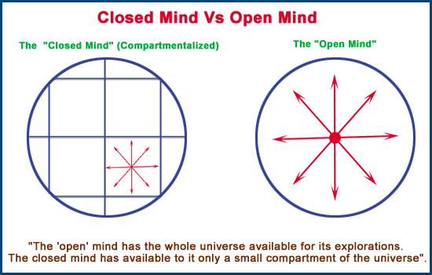
Initially, our ideas may even be ‘wrong’ or ‘misdirected’: often, our initial wrong ideas on an issue could lead to the ‘right’ ideas. As we explore our mental models, our minds as ‘learning systems’ would automatically tend to correct the errors and mis-directions in the initial models. Such an ability to correct itself is an intrinsic characteristic of the human mind – however, we do need at all times to present the mind with the clearest possible pictures of the realities confronted to enable such self-correction to be done effectively.

What we need to do is to enable the open mind to ‘see’ its own ideas with utmost clarity. Graphical pictures of the reality confronted by the mind and described by its mental models could help enhance the clarity with which the mind is able to ‘perceive’ the complex reality it confronts, correct itself as needed, and thus find the right direction. Further, such pictures would also directly aid innovation per se because graphical pictures can be powerful stimulators of human imagination.

One essential requirement here is the ‘open mind’. If the mind is tightly ‘closed’, then nothing can get in, and no innovation can take place. If the mind is open, then the whole world is available for its explorations as depicted above (see “Closed Mind Vs. Open Mind”). However, appropriate tools are required that can help the open mind to alter and correct its mental models.

Linear Thinking Vs. Multi-linear Thinking:

To create and innovate, we need to look at things from different angles, diverse perspectives. But the conventional ‘prose mode’ of thinking that has been drilled into our minds through the educational system usually hinders approaches that could lead to creativity and innovation. The ‘graphical mode of thinking’, which enables multi-linear thinking, helps us to look at things from a multi-dimensional perspective, as we all used to do when we were children. (For example, check out the way a little child asks questions, often jumping from one topic to another, seemingly at random – but actually dictated by the needs of his or her own mental models driving the unrelenting process of growth and development. This ‘question-asking’ is obviously not a linear process at all – in fact, the question-asking frame of mind that all children possess is the very heart and soul of creativity).
Linear thinking is the ‘standard’ rational, rule-based way of looking at things. Linearity is characterized by sequential occurrence of events; it is usually driven by simple ‘rules’; linearity is generally driven by simple rules of rational logic.

Examples of linear processes: • 1+1 = 2 (and most of arithmetic);
• standard “Newtonian physics” (linear) Vs. Quantum Physics (multi-linear)
Multi-linear thinking is the integration of rational, creative and perceptive processes (going beyond standard rules) – enabling the mind to look at things with a ‘fresh’ perspective.
Multi-linearity need not have a sequential occurrence of events; rules, if any, that drive multi-linearity are not at all simple (and they may not easily be even discoverable); multi-linearity involves aspects of perceptions, creativity which may be bundled with more complex forms of logic.

Examples of multi-linear processes: • changes in weather, which cannot easily be forecasted • creativity and other processes of the human mind, which cannot be bound by any rules that we know • the phenomenon of ‘inspiration’ which is complexly linked to the mind’s inherent powers of creativity and also to the prior experiences and understandings of the ‘inspired person’, and to other subtle things that we may not even be able to describe in just words.

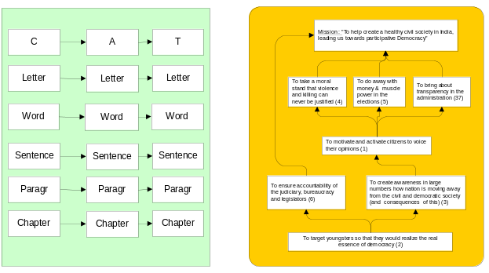
Prose may be described as fundamentally ‘linear in structure’ because it follows the construction rule illustrated in the thumbnail sketch at left alongside (this may be seen in full in the Appendix). However, real life is not linear at all – it is inherently ‘multi-linear’; multi-linearity is also illustrated alongside to contrast with the model of linearity seen in prose. Several multi-linear models are seen in detail in the Appendix. We want to observe here that our educational systems have trained us very well in the ‘prose (or linear) mode’ of thinking – and have barely ever sought to inculcate the multi-linear mode of thinking that is required for innovation.
Linear Structure
of Prose

Model showing
Multi-linearity

III: How to enable Innovation?

Organizations always involve ‘management’ – but an organization seeking to innovate must learn that many of the rules of ‘rational management’ simply do not apply. The box on “Enabling Innovation” outlines some important factors involved in enabling innovative thinking by individuals and groups.
Enabling innovation
(of the organization as a whole)
Some of the important factors involved in innovation by an organization:
-- • ‘Open’ minds • Mapping Mental
Models
• Activating Multi-linear Thinking
-- Tools + process for recording ideas
-- Tools + process for enabling: • group
dynamics; • free flow of ideas from
individuals comprising group • an ‘idea
-enabling’ culture (see ‘Effective systems’
below for some info. on important
aspects of such a culture in the
organizational setting).
-- Tools + process for organizing
(‘structuring’) ideas
-- Effective systems in place for:
i) rewarding good ideas that work out
ii) appreciating ideas that may not work
out at the beginning but which may
have potential
iii) ensuring that ideas that may fail are
NOT punished (as many good ideas
may not be successful to begin with),
Only INACTION what is not
acceptable.

It is widely acknowledged, for instance, that organizations should be designed to seek the effective management of resources of various kinds. If ‘innovation’ is perceived as a resource in the organization, then innovation does need to be enabled in the organization as a whole – and when the innovation process brings about ideas for innovations, then those ideas have to be used effectively so as to create and deliver wealth.
We may term the process (of enabling innovation in general and then bringing innovations into practical use) as “management of an enabling environment for innovation and using the products of innovation” – i.e., “Managing For Innovation” (MFI) (rather than ‘Management Of Innovation’). The process of MFI is in many respects entirely unlike what is conventionally regarded as ‘rational management’. As a leading thinker on creativity and innovation has acutely observed: “If it's creativity you want, you should encourage people to ignore and defy superiors and peers — and while you're at it, get them to fight among themselves. You should reassign people who have settled into productive grooves in their jobs. And you should start rewarding failure, not just success; reserve punishment only for inaction.” (Robert I. Sutton, Harvard Business School Working Knowledge, Jan 14, 2002).
IV: Managing Innovation?

It’s actually all about… “Managing for Innovation”!

Innovation creates wealth from underutilized and unutilized resources. It’s a process that brings about breakthroughs in products, processes, practices in society…at the individual and the organizational levels. Innovation means managing the generation and implementation of ideas by enabling, exploring and, finally, exploiting the potential creativity of human minds – which is the ‘nursery’ of all new ideas leading to innovation.
Innovation is all about Ideas! It derives from the generation, the structuring, and the engineering of ideas to a specific innovative purpose.
Ideas are like seeds, they need…
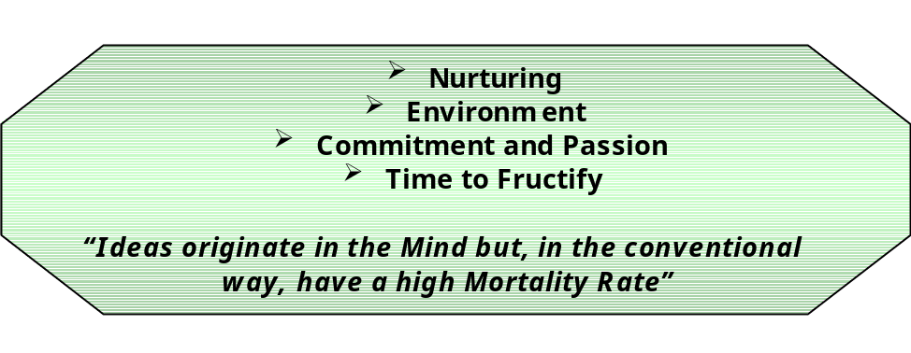

Ideas are like seeds that need nurturing to make them sprout and grow into trees. The growth of a tree takes time – it can never be an ‘instant’ process like instant coffee or fast food. Is there a well-established procedure to guide the organisation from the generation of ideas to growing commercial products out of those ideas?

In conventional management, there are bits and pieces of techniques and methods for idea generation, idea management, etc. But, there is enormous scope for enhancement of this entire process into real ‘idea engineering’. Using existing methods, if in one case there is an excellent ‘idea generation’ technique then ‘idea capturing’ is missing. In another case, if there exists a good ‘idea-capturing’ technique then ‘idea structuring’ would be weak. Invariably there exist missing links in the process that we need to ensure idea engineering for innovation.

Innovations are about ‘managing’ the mind’s cognitive style: that is, the logical AND the creative aspects of thought need to be handled effectively. Thought (which is the result of and results in mental models) involves human behaviour with all its potential for conflict. Often, human intuitions and the behaviour stemming therefrom may seem to contradict the conventional logic.

We note that humans as individuals and as groups have successfully accomplished Missions in the past only when they have successfully resolved such seeming contradictions - by whatever means: in essence ‘logic and intuition’ have to be effectively integrated. Any process for the ‘engineering of ideas’ mentioned above must therefore enable such resolution and integration of possible contradictions between logic and intuition. We paraphrase from Rubinstein and Firstenberg in their influential book, ‘The Minding Organization’:
The rules of logic, which have evolved over two million years, have been captured and are readily available in computers. In contrast, creativity has been evolving over several hundred million years…it cannot be captured within the defined boundaries of rules. For instance, a computer can perform complex mathematical calculations in mere fractions of seconds but it is incapable of recognizing a person after a decade – something that the mind does in a fraction of seconds. These are about perceptive skills not just the analytical skills. Innovations are not about management of just ‘perceptions’ but of heightened perceptions.
A pot-pourri of anecdotal illustrations about various aspects of innovation

Scotchgard is the brand name of a fabric protector. In the 1950s, researchers in 3M were testing various fluoro-chemicals for use on aircraft. A little of some chemical spilled on a researcher’s tennis shoe. With the passage of time she noticed that as her tennis shoe got dirty from wear, one area remained clean. She recognized this as the spot that been touched by the spilt chemical! Scotchgard was the outcome of an error and a heightened perception.
Error + Heightened perception leads to innovative success

The 3M ‘Post-it Pads’, when the glue was tried first, was considered to be a failure because the perception was that the glue should be used for a strong connection. It was only when the perception was changed to situations requiring weak connections that the glue that appeared to be a failure in one context became a remarkable success in a new context. Innovation is about facilitating the process of generation of new mental models in continuum to a context.
Changed perception leads to innovative success

Alexander Fleming, a bacteriologist, one day arrived at his research lab to find that he had left one of his experimental plates containing the staphylococci bacteria near a window – and quite by accident, some mould had been deposited on the plate. Unlike others who would have overlooked the mistake, Fleming investigated the error by examining the plate thoroughly. He found, under the microscope, that although mould covered one portion of the bacteria, around the mould there was a clear zone. He inferred that the mould was evidently dissolving the bacteria. His articulation of the error and investigation of it gave penicillin to the world. Articulation of thoughts and errors is an important aspect in the process of innovation.
Innovation through investigation of an error

Edward Land, the inventor of Polaroid, was asked by his daughter “why do we have to wait to see the pictures?”…the recording of that simple question and thinking about it led to the innovation of Polaroid…innovation is about encouraging the questioning ability of the human mind and concurrently enabling the recording of ideas as responses to simple questions.
Innovation as a result of heightened perceptions about a simple question!

Eric Von Hipple of MIT studied of the sources of innovations in the electronic industry, and indicated that 70% of product innovation comes from users. It’s not about managing a single user but a group of users…it’s about providing an environment of collaborative culture for wholehearted user involvement.
Innovation as result of understanding user needs

Edward de Bono’s renowned theories about “Lateral Thinking”, which established him as one of the prime “gurus” on creativity and innovation – his ideas, in fact, may well be described as creative thinking about creativity, innovative thinking about innovation!
Innovative thinking on Innovation!

“Managing for innovation”
is rather different from ‘conventional management’!

‘Managing for innovation’ is about managing people’s minds, their ideas, their insights, and their intuitions so as to enable the creation of value. In essence, it requires creation of an appropriate environment for enabling innovation. ‘Managing for innovation’ is about managing the thinking frames of reference, the mental models. It is about managing the articulation of ideas and thoughts, including errors, and is about managing the peoples’ ability to question assumptions, the context of ideas – it differs significantly from conventional ‘rational management’.
Managing for innovation encompasses a whole gamut of things… creation of ideas, clarification in the mind, classifications into new frames of references, effective communication of new mental models, adequate comprehension of these new ideas by others, provision of a collaborative culture to nurture the generation of new ideas and finally the commitment of the organization to translate innovative concepts to viable commercial propositions, creating real value.
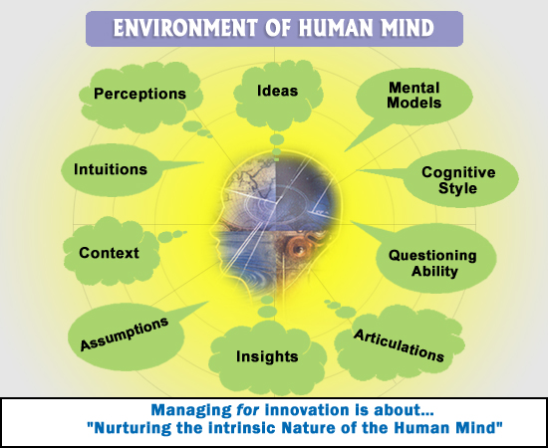

7-‘C’ Framework:
Simple question: Are organizations equipped with an effective framework to manage the spectrum of activities involved in the process of innovation? In their own way and within their available capacities people within organizations have always been practicing innovation (if encouraged to do so). However, based on the limited framework that conventional management provides, what occurs is in general only ‘inadvertent innovation’ – not a practice that could lead the organization to continuous innovation.

Organizations need a well-structured, scientifically based, easy-to-use framework to ‘manage innovation’. We propose the “7-‘C’ Framework”, illustrated in outline below, as an appropriate candidate framework to fill the current gaps so as to enable ‘Managing for Innovation’.

This 7-‘C’ Framework is composed of the elements of:
•Creation, •Clarification, •Classification, •Communication, •Collaboration, •Commitment and •Culture.
We have to weld all of these elements together into a practical working system. The outline sketch for such a framework is illustrated above. (This illustration may be regarded as an important ‘mental model’ devised by the second author to explain some of his central thoughts on the issue of ‘innovation in organizations’ to the first author, which then became a useful conceptual framework for the thesis of this article).
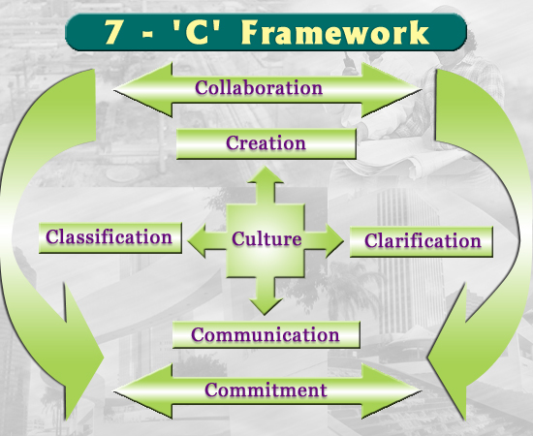

Brief descriptions of each of the elements in the 7-‘C’ Framework are provided below, and then we describe the ‘generic design’ that enables development of the needed ‘Formal System for Innovation’ for making innovation a practice in the organization.

Creation of ideas through a variety of ‘idea generation’ techniques - Nominal Group Technique (NGT) for one - and enabling further creation of ideas by way of a series of focused trigger questions. Ideas are not isolated entities; they are bundled with the creators’ perceptions, embodied with underlying assumptions and personified with connotations in different contexts. Thus the creation of ideas will result in the need for further clarification of many things that lie beneath.

Clarification of ideas through structuring (organizing): this is about questioning the underlying assumptions, and the contexts. The renowned system scientist John Warfield’s Interpretive Structural Modeling (ISM) is the modeling technique par excellence to establish the relationships between the ideas using the ‘Socratic Method of questioning’. (Ref: section on Interactive Management for more on ISM)

Classification of ideas is about inserting ‘elementary’ ideas into appropriate categories to enable insights and interpretation of those ideas. John Warfield’s Field Representation (FR) is another powerful modeling technique for categorization of ideas into new frames of reference thereby enabling people to inter-relate these new frames of reference. (Ref: section on Interactive Management for more on FR)

Concurrently the creation, clarification and classification of ideas are integrated into an organized framework so as to enable insightful interpretations. Both ‘clarification’ and ‘classification’ (as defined above) are powerfully enabled through Warfield’s seminal contributions to the design of ‘general systems’.

Communication … The process ensures that structured documentation becomes available via a combination of graphical models and prose on what Bill Gates has termed as the “digital nervous system of the organization”, thereby rendering communication highly effective. Comprehension by users of this structured documentation is significantly enhanced at all levels. The ISM and FR modeling processes - along with the prose descriptions of underlying assumptions - ensure crystal clear interpretation of ideas along with their contexts, significantly eliminating potential ambiguities.

Collaboration … This process is collaborative where each and every participant is given full opportunity to articulate and communicate his/her ideas. The democratic nature of the process enables everybody in the organisation to participate – and because everybody’s good ideas are included in the Action Planning, motivation is significantly enhanced. The participants’ contributions through this process can transcend the limitations imposed by organizational hierarchies.

Commitment from top leaders is essential for creating the innovative culture in the organization and for enabling it to take root and grow. Both ‘mind share’ and ‘money share’ need to be allocated at all stages of the innovation process – right from germination of an idea to harvesting the products/services arising from it, from concept to commercialization.

Culture is generally about providing the right environment for the creation of new ideas that could lead to innovation and the sharing of those ideas amongst members of the organization. Communication is human “nature” but knowledge-sharing is human “nurture”… encouraging sharing of thoughts, learning; rewarding success and punishing only inaction not failures in organization. The culture demands the building up of interactive communities within the organisation for fostering innovative practices in various areas.

The complete 7-‘C’ Framework, as it is implemented in an organization, becomes the harbinger of cultural change enabling creative vitality right across the organization. It initiates, enables and ensures the metamorphosis of organizations into living organisms. In an organization using the 7-‘C’ Framework, innovation no longer remains a by-product of research and development efforts or for that matter an outcome of a crisis…it becomes a regular practice right through the entire organization, at all levels.

Making Innovation a Practice:

To make innovation a practice in the organization would require considerable work, re-work and modifications to be carried out on existing ideas and mental models held by individuals and groups in organization.

- Being innovative is not a chance event - the mind can be trained to think in newer, more diverse and creative ways. The organization requires an effective framework for training the mind continuingly to enable individuals and groups to think in the more diverse and creative ways needed.
- Creating a “process framework” for innovation as a practice demands top management involvement!
- Practical tools are required that would enable: • Question-asking • Gathering of ideas • Organizing available ideas to ensure effective action.
- Encouraging and enabling the question-asking process right through the organization is fundamental for innovation – this is the simple evolutionary step that could lead to the needed creative revolution in the organization.
The picture below illustrates the important idea that a natural evolution in concepts - through re-training our (individual and group) minds to think in new, more creative ways (specifically using ‘the graphical mode’ of thinking) - “could lead to” a creative revolution in organizations – a revolution leading to innovation in the organization as a regular and systematic practice (which is powerfully enabled by what is known as Interactive Management).
Evolution in concepts
A Creative Revolution
in the organization
Continuous
Innovation

Interactive Management:

“The whole of science is nothing more than a refinement of everyday thinking” --- Albert Einstein

As discussed, innovation is the ability to come up continuously with ways and means, products and processes, which are new and different from those of the past and present.

Innovation requires changing our existing reality – this would generally involve changing our own and others’ thinking in various ways, which is a very complex issue. The renowned systems scientist, John N. Warfield investigated ‘complex systems’ with a view to enable design of systems for the convenience of human beings rather than vice-versa, i.e. forcing humans to change themselves to fit into existing systems.

Based on this fundamental motivation, he propounded the ‘structural approach to systems science’ as a way to enable people at large to understand, investigate and design ‘complex systems’ using natural and intuitive everyday language. This approach led to the development of a set of systems methodologies to enable people:
Interpretive Structural Modeling (ISM)

Warfield created a powerful modeling tool, ISM, a grand generalization of ‘PERT/CPM’. ISM enables any ‘transitive’ relationship in a system to be easily represented, so that we can create graphical representations of our mental models about the system regardless of its complexity. These models are intuitively appealing and effectively communicated at all levels – while being scientifically entirely sound and rigorous. In the Appendices we have provided an illustration of an ISM developed by an organization for its own practice.

• to create, record and clarify their ideas about an issue (through significant enhancements of what arose as brainstorming), and then
• to ‘structure’ (or organize) those ideas based on appropriate relationships depending on the context of the situation. This is accomplished through powerful ‘modeling techniques’, such as ISM and FR described in the boxes.
Field Representation (FR) Method

Warfield developed another powerful structural modeling tool, the FR method, to enable clustering of elements in a system according to the similarities perceived between the elements (NOT according to pre-conceived categories). The FR methodology enables the linking up of ideas within the same or different clusters. (An illustration of a Field Representation may be seen in the Appendices).

The above-noted approach powerfully enables the needed “refinement of everyday thinking” for people to arrive at clear understanding of the context and inter-relationships between the elements of the complex systems being treated in innovating on any product or service. The set of methodologies embodying the structural approach to systems science has since become known as Interactive Management (IM), which has seen a wealth of applications to complex issues of all kinds in organizations like Ford, John Deere, IBM, a number of other Fortune-500 companies, the World Health Organisation, and others.

“The development of IM is based on the recognition that for coping with complex situations, there is a need for a group of people, knowledgeable of the situation, to tackle together the main aspects of concern, to develop a deep understanding of the situation under analysis and to elaborate the basis for effective action: all these founded in a spirit of collaboration, commitment and within the framework of a serious and organized effort”. (Ref: --- Warfield & Cardenas).

The most contentious issues confronting organizations are in capturing, organizing and managing ideas for innovation. At every stage of an organization’s history, ideas available with its people have the inherent potential to create wealth for the organization – but this can happen only if those ideas are articulated, captured, clarified all round and effectively used. In conventional management practices, much of the tacit knowledge available with individuals in the organization is not readily available for the organization to derive benefit from it. Using ideas is generally a matter of organizing and managing them – this is enabled with high effectiveness through the Interactive Management processes.

The ‘One Page Management System’ (OPMS):

The practical system tool that encapsulates the 7-’C’ Framework and the underlying principles for innovation is called the ‘One Page Management System’ (OPMS) – an application of Interactive Management - for organizations to actualize the process of innovation as a systematic practice.

The OPMS as a concept has its genesis on the fundamental premises of General System Theory, the Science of Generic Design and the practice of Interactive Management.

The OPMS enables the user to crystallize, onto a single page, all aspects of all issues tackled during progress towards any Mission – with no loss of information whatsoever, as all lists of ideas and all graphical models created are readily available at the mere click of a button. A ‘One Page Management System’ is illustrated below.

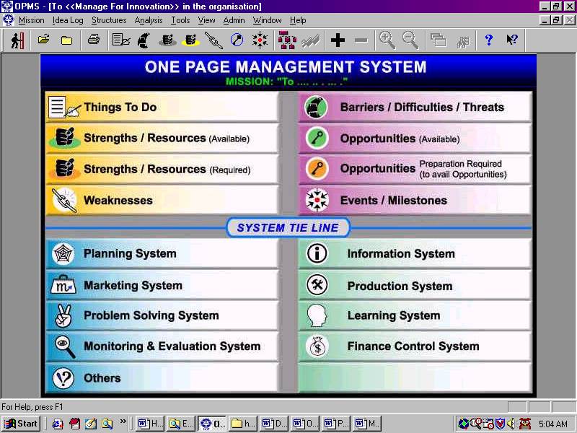
The Process of OPMS (See picture on page 26). In brief, creating a ‘One Page Management System’ involves:

- Identifying any challenging Mission
OPMS principles strongly emphasize clear articulation of the situation and enables continuing clarification as the OPMS process continues.
- Generating ideas about the Mission in six ‘fundamental Dimensions’ ( Things to Do  Barriers  Strengths  Weaknesses
 Opportunities  Events/Milestones) by responses of group to carefully chosen ‘trigger questions’.

- Linking up these ideas with each other and the Mission using appropriate relationships.

This part of the OPMS process involves creating models showing how the ideas of participants about the situation are related to each other and how, specifically, they may impact on each other and the Mission. This is done in a highly collaborative manner. As the linkages are articulated and understood, fresh ideas come into being by way of the intrinsic feedback loop created in the minds as part of the OPMS process.

- Integrating all ideas through linking up the various Dimensions in the OPMS
This part of the OPMS powerfully enables transformation of ‘ideas’ into ‘actualities’ by processing them within the various systems, sub-systems and functions set up in the organization. The allocation of resources is mandated from top management, who are thereby committed to the identified Mission.
Power of Perception
Verbalization of Intuition
Articulation of Thoughts
Ability to Question
Motivation thru’ Empowerment
Commitment thru’ Involvement
Learning thru’ Collaboration
…

Underlying principles of the OPMS Process--
Facilitates Innovation!

Logic excluding intuition, and intuition excluding logic are both dangerous. Logic and intuition working together can form the foundation of true reasoning and wisdom – and this is the basis of the OPMS approach.

OPMS is not merely about ‘technology’ – it is actually an integration of human behavioral issues with a useful ‘enabling technology’ to optimize the effectiveness of human ideas and effort; technology – in particular, the computer – is used as tool somewhat in the way the carpenter or the sculptor uses his chisel to create and hone…
Nokia:
“The future doesn’t belong to people who know technology but to technology which knows how people work”

The complete OPMS process, as it is implemented in an organization, becomes the harbinger of cultural change (like Stephen Covey’s “7 Habits…”) enabling creative vitality right across the organization. It initiates, enables and ensures the metamorphosis of organizations into living organisms.

A Glimpse of Some Features & Outputs of the OPMS Process…

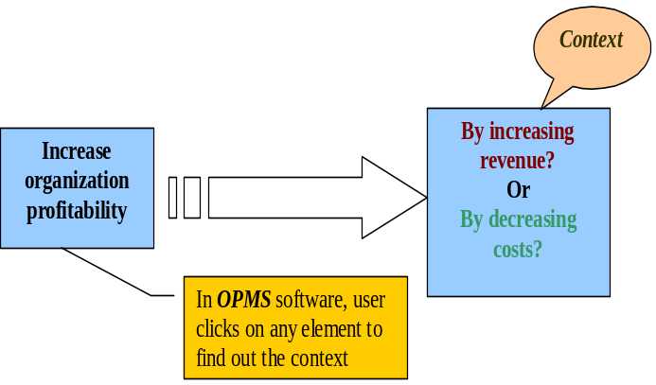
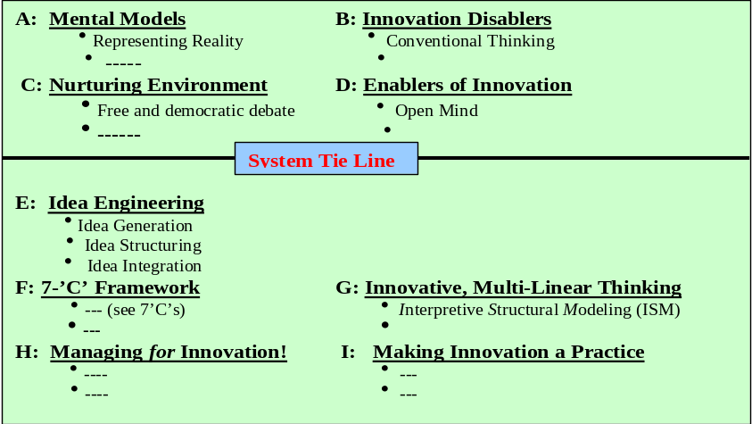
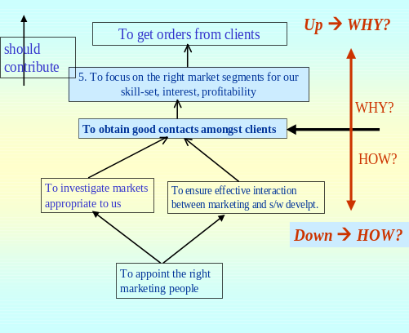
Context: Clarification of context directly about the elements using OPMS
Does
By increasing marketing strength of the company.

Contribute to

Doubling company’s turn over within one year.

Questioning: OPMS process invokes question to help validate the assumptions
Yes
No
WHY?
New Frames of Reference: Above picture is a Field Representation developed as part of the OPMS process used to write this article
Structuring: OPMS process enables organizing the thoughts
Application of OPMS Process ---
--- Makes Innovation a Practice!

V: Proposition: A Practical Tool to ‘Manage for
Innovation’

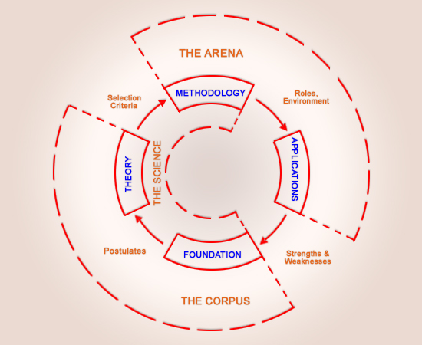
Based on Warfield’s “Domain of Science Model”, which “furnishes a way to describe what should make up a science”, we propose a practical tool to enable Managing for Innovation in organisations. (Ref: “A Science of Generic Design, John N. Warfield, 1994, page 115).
Domain of Science Model
The “Foundation” incorporates ‘the human being’, ‘language’, reasoning through relationships’. Theory contains ‘laws’, ‘principles’ and explanations of these. Methodology provides the situational guidance appropriate to applications. Applications involve workable models usable by organizations.

Foundations - “Innovation is implementing new ideas (new ways) to create value”. Innovation is nothing but the discovery of new ways (new mental model) of creating wealth for the individual, the organization, or for society as a whole. Graphical pictures of the reality confronted by the mind and described by its mental models enhance the clarity with which the mind ‘perceives’ reality. What we need to do is to enable the open mind to ‘see’ its own ideas with utmost clarity. Real life is not linear, it is usually multi-linear – and we need to perceive an integrated picture that reflects this multi-linearity. The foundation of the process of innovation involves the open mind, multi-linear thinking and the mapping of mental models.
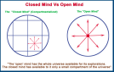
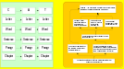
Theory: ‘Managing’ for innovation’ is about managing people’s mind, their ideas, their insights, and their intuitions – in essence, this means the creation of an appropriate environment for enabling innovation.’ It is found that a significant number of the contradictions that do arise between ‘conventional logic’ and human behavior are usually resolved very satisfactorily through the principles and laws of Interactive Management based on the Science of Generic Design.
Methodology: Organizations need a well-structured, scientifically based, easy-to-use framework to ‘manage for innovation’. In an organization using the 7-‘Cs’ Framework, innovation no longer remains a by-product of research and development efforts or for that matter an outcome of a crisis…it becomes a regular practice right through the entire organization, at all levels.
Applications: The One Page Management System (OPMS) is a tool that encapsulates the ‘7-Cs’ Framework to effectively manage for innovation. OPMS is a process framework for practical work on all individual and organizational issues – it is a very natural and intuitive way for the mind to do its work. In other words OPMS as a process “stimulates and simulates” the mind: the OPMS can appropriately be described as an “Operating System for the Human Mind”, designed to transform organizations into organisms.

***

VI: References

A: On Innovation Process and Management Practices for Innovation:
- “The Act of Creation”, Arthur Koestler, 1964
- ‘Value Innovation Perspective in Indian Organisation’ – P.R. Mohanty in South Asian Journal of Management, Vol. 6, Issue No. 2, April-June, 1999
- ‘The Minding Organisation’ – Moshe F, Rubinstein, Iris R. Firstenburg, Wiley, 1999
- “The Art of Innovation”, Tom Kelley, with Jonathan Littman, Harper-Collins Business, 2002
- “Effective Innovation”, John Adair, Pan, 1996
- “Serious Play”, Michael Schrage, HBS Press, 1999
- “Knowledge Management” – Harvard Business Review, HBR Press,
- “Theory of Constraints” – Eliyahu M. Goldratt, North River Press, 1990
- Peter Drucker on “Innovation and Entrepreneurship”, Harper Perennial 1993
- “Lateral Thinking”, Edward de Bono,
- “Serious Creativity”, Edward de Bono
- Handbook of Technology Management, edited by Gerard H. Gaynor, McGraw-Hill, 1996 – Chapter 9: “Managing Technology-based Innovation”, by Hans I. Thambhain, Chapter 10: “Innovation: Managing the Process”, Marv Patterson
- “Mind Mapping”, etc., Tony Buzan
- “7 Habits of Highly Effective People”, Stephen Covey
- “In Search of Excellence”, Tom Peters
- “Managing Radical Change”, Sumantra Ghosal and others, Viking-Penguin, India, 2000
- “Business @ Speed of Thought”, Bill Gates, Penguin, 1999
- “Reasoning, Learning and Action”, Chris Argyris, Jossey-Bass, 1982
- “Requisite Variety and its implications for the control of complex systems”, W. Ross Ashby, Cybernetica, 1958
- “Fuzzy Thinking”,
- Websites: <<www.innovationtools.com>>

B: On ‘One Page Management System’ (OPMS)

Documented work on the OPMS comprises of:
a) Reports created following OPMS Workshops for various organizations (Item 1 below refers to some of these Reports)

Reports on a sizable number of OPMS Workshops conducted for various organizations and individuals on a variety of issues, all involving the development of innovative culture in the organizations or by the individual, e.g.: • Dr Reddy’s Foundation, Hyderabad • ITC – International Business Division, Hyderabad • Bank of Maharashtra, Pune • IOCL, Chennai • Systems Research Institute, Pune • Crompton Greaves Ltd, Nasik • Centre for Excellence in Organisations, Chennai • Institute of Public Enterprise, Secunderabad, • Presentations at IIT, Mumbai, FICCI, Chennai, NIPM, Chennai, etc • etc.

b) Published and unpublished articles and PowerPoint Presentations regarding various aspects of the OPMS, broadly outlined below.

- Article OPMS – an ‘Operating System for the Human Mind’, in Indo-US Business, December 2000
- ‘How a Child Learns’, G.S. Chandy, 1999
- ‘The Hierarchy of One Page Management Systems in the Organisation’, G.S. Chandy, 1999
- “Major Steps in Creating an OPMS”, G.S. Chandy
- “Efficiency Vs Effectiveness”, G. S. Chandy
- The OPMS Manual, by GS Chandy, private publication (1994); republished in 2000 for our Workshops and for development of our software
- Forthcoming: The New OPMS Manual including information about the OPMS software
- URL at <www.angelfire.com/space/opms>, where some of the available documentation on the OPMS has been made available for reference

C: On Interactive Management & the Science of Generic Design (the basis of the OPMS)

- ‘Societal Systems: Planning, Policy and Complexity’, John N. Warfield, Wiley, 1976
- ‘A Science of Generic Design: Managing Complexity Through Systems Design’, John N. Warfield, 2nd Edition, Iowa State University Press, 1994
- ‘A Handbook of Interactive Management’, John N. Warfield and Roxana A. Cardenas, Iowa State University Press, 1994
- ‘Essays on Complexity’, John N. Warfield, Reviewer Copy, 1997
- ‘A Structure-Based Science of Complexity’, John N. Warfield, Reviewer Copy, 2000
- CD-ROM, 1999, including a sizable section of Warfield’s papers

D: On General Systems Theory (the basis of ‘Generic Design Science’)

- “Systems Thinking”, edited by F.E. Emery, Penguin Education, 1981
- “Introduction to Systems Philosphy”, Erwin Laszlo, Gordon & Breach, N.Y., 1972
- “On the Effectiveness of Research & Development Organisations”, Chris Argyris, Am. Science, 56(4), 1968
- “Essays on the Structure of Social Science Models”, Herbert Simon, MIT Press, 1963
- “The Design of Enquiring Systems”, C.W. Churchman, Basic Books, N.Y., 1971
- “The Psychology of Science”, A.H. Maslow

VII: About the Authors:

1) G S Chandy, Researcher-Scientist

Director, Interactive Logicware Ltd, studied engineering at Bangalore and was a graduate scholar in the Math. Department of Brandeis University, Mass, USA. He has over 30 years of rich experience in a variety of fields, including research and development into System Science, Interactive Management, and management consulting and advertising, creative writing, journalism, entrepreneurship - and just wandering around in the Himalayas. He has been Creative Director of one of India’s leading advertising agencies. As a journalist, he has published in many leading newspapers and magazines, including the Times of India, Hindustan Times, Statesman, and he wrote a controversial satirical weekly column called ‘Tonic for Thought’ for Deccan Herald, Bangalore. Following his first interaction with the renowned systems scientist, John N. Warfield, during a seminar series in India hosted by TCS (on the systems studies that led to Interactive Management), he has subsequently focused entirely upon research into Interactive Management, which led to the development of the One Page Management System (OPMS) concept. During the last decade he has been conducting extensive workshops on OPMS for making it a universal practice.

2) Nihar R. Pradhan, Management Consultant

Freelance management consultant, an engineer from REC Jalandhar, with an MBA from ICFAI Business School, Hyderabad. He has over 6 years of rich experience in the field of business development and management consultancy. He started his career in Business Development in an MNC, followed by management consultancy specializing in the areas of Knowledge Management, Process Re-engineering for leading organizations like ITC, EID Parry, Dr. Reddy’s Foundation, etc. His fundamental inclination for the subject of Knowledge Management led to his exploration of the concept of OPMS

His inherently strong passion for articulation has resulted in publication of a number of articles on management education and practices in the leading newspaper and magazines like “The Economic Times”, “The Hindu”, Banking Frontiers, etc. He has to his credit the publication of three booklets on KM, ERP and E-Com.

VIII: Appendices

Appendix - 1

What is modeling? The Structural Modeling Approach – and how it is significantly different from any conventional approach

First, a quote from John N. Warfield:
Modeling is a process that begins with human perception. A sequence of the following nature describes the activity of modeling:

- Perception
- Storage in the brain
- Identifying a context within which to place the perceptions, and within which they can potentially be integrated
- Generating factors associated with that context and with the perceptions that are the focus of attention at the time
- Identifying types of relations that appear to be associated with these factors in the chosen context
- Structuring the factors to show how they are interrelated through specific relationships that are representative of the selected types
- Interpreting the structures produced
- Associating the factors with algorithms that permit the relationships discovered to be quantified (if they are possible to quantify)
- Assigning or computing numerical values to/for the factors
- Interpreting the model-related information for purposes of design or decision-making
(Above paraphrased from “Structural Thinking”, J.N. Warfield: 1995-96 Essays on Complexity)

The above sequence describes Structural Modeling, the process underlying Interactive Management (and its child, the One Page Management System). Built into the above-outlined Structural Modeling process, when IM or OPMS is used, is an ongoing comparison of model-related information at each stage with the reality on the ground. These comparisons become sharper and more focused as the models evolve and develop over time.

The conventional way (which the IM or OPMS process would not allow at all) is to start at Step 8 or at Step 9 of the above-outlined modeling sequence.

In fact, most discussions between people not using IM/OPMS start out at Step 8 or Step 9, usually leaving out Steps 1 to 7, which are pre-requisite for clear understanding all round! (It is true that there are, on occasion, some context-clarifying remarks made, but these generally lack adequate focus to ensure truly clear understanding all round). Thus, many discussions between people are, in the conventional way, based on sets of ‘mental models’ that are significantly different from each other because of differing backgrounds of the people holding them. These mental models on which different people are basing their discussions are left entirely unclarified. Because of the differences in context, the very same words spoken by different people could often mean significantly different things. In any case, the context is entirely unclear. This leads to non-understanding, misunderstanding, confusion, and, finally, ineffective or incompetent action.

We are interested in ensuring effective action at every level in the organisation – starting with the individual. Because discussions in the Structural Modeling process are always based on a significant clarification of the context of each idea and thought contributed to the discussion by each person, subsequent action is much more likely to be effective. (Step 3 of the sequence of Structural Modeling outlined above).

It should be observed that ‘Structural Modeling’ INCLUDES the ‘conventional modeling process’. The conventional ‘numerate models’ (showing numbers, e.g. how much money, how many copies will be sold, and so on - on which most people rely to the near-total exclusion of any structuring activity) will develop, in a natural way, as the structure of the interrelationships of various issues becomes clear. The difference is that the numbers developing through the Structural Modeling approach are based on a detailed consideration of all structural aspects of the issue, and will therefore have far higher reliability than the numbers made in the usual approach.

Appendix - 2

The ‘Deep Logic’ of an Issue
© G.S. Chandy, Dec 2001

Every issue that we discuss or think about contains – or could contain - layers and layers (and still further layers) of meaning. The term ‘deep logic’ refers to these layers and further layers.

Our ‘conventional prose forms’ of thinking and communicating (whether we do the latter orally or in writing) do not enable us to explore or understand, effectively, the deep logic of any issue. Some deep thinkers (philosophers, scientists, mathematicians, legal luminaries, writers, political intellectuals) are indeed able, because of prior education or training, to probe deeper into an issue than others. However, the ‘conventional prose forms’ impose very stringent limitations on the kind of thinking that is possible by anyone, regardless of his/her training, background or inclination.

For example, consider the following assertion:

“To enhance creativity and intellectual productivity should contribute to effective problem solving”

Most people might agree with this assertion. If not - no problem: just take it as a mere assertion, an assumption, with no ‘truth value’ contained in it. Our claim, in any case, is that the conventional mode of thinking does not enable us to explore much further than the assertion itself. Yes, we can discuss around it just a bit – but not much progress is possible. Professor John N. Warfield’s (JNW) seminal contributions to ‘systems science’ enable us to explore that assertion to the depth and in the degree of detail desired at any point of time. For instance, see model below created using JNW’s Interpretive Structural Modeling (ISM), for a quick exploration of part of the ‘deep logic’ of the above assertion. (Many other, and if required, much deeper, explorations are possible). The ‘One Page Management System’ (OPMS) is found to be the practical tool par excellence for the exploration of deep logic of any issue of interest.

Mental Models & Problem Solving
(Read bottom upwards. Each arrow means “contributes to”)
2. To aid problem solving

1. To create a framework for Decision-Making

6. To enable Knowledge Management

Should contribute
3. To enhance creativity
7 To enhance intellectual productivity

4 To enhance Idea Management

5 To map Mental Models clearly, in a usable way

Appendix-3

Illustration 2A: The Linear Structure of Prose - and of conventional
thought
[Adapted from “The Linear (Precedence) Structure of English Prose”, page 81 of “Essays On Complexity, 1988-1994: Procrustes is Alive and Well and Teaching Composition in the English Department”, J.N. Warfield]

EXAMPLE: Letters: {c, a, t} Relationship: “directly precedes” represented by
‘ ’
word
letter
letter
letter
=
sentence
word
word
word
=
c
a
t
paragraph
sentence
sentence
sentence
=

chapter
paragraph
paragraph
paragraph
=

book
chapter
chapter
chapter
=

The above relentlessly linear structure of prose, in which we have been educated and trained all our lives, now totally dominates all our thinking processes – whether we work alone or in groups. But real life is not linear at all! –-- It is much more like the Interpretive Structural Models illustrating this article. A brief retraining will re-enable us to think ‘multilinearly’ once again, as we all used to do when we were children (remember how children ask questions? – not a linear process at all).

It will be found that such pictures as illustrated above are much easier to read, understand and remember than the full prose translations of those models - especially when the models increase in size to represent larger sections or more detail of the reality confronted. (Check out some larger models provided as examples in the Appendices).

There are several other significant benefits in the ‘graphical mode of thinking’ as here recommended, as opposed to the conventional ‘prose mode’ of thinking that has been drilled into our minds through the educational system. (For example, compare the picture of the ‘Linearity of Prose’ versus the ‘Multi-linear Nature of Reality - Appendices).

Appendix 4, next pages
Appendix-4

Some Practical Models developed using the OPMS Process
Practical Models developed for Organizations in live OPMS Workshops

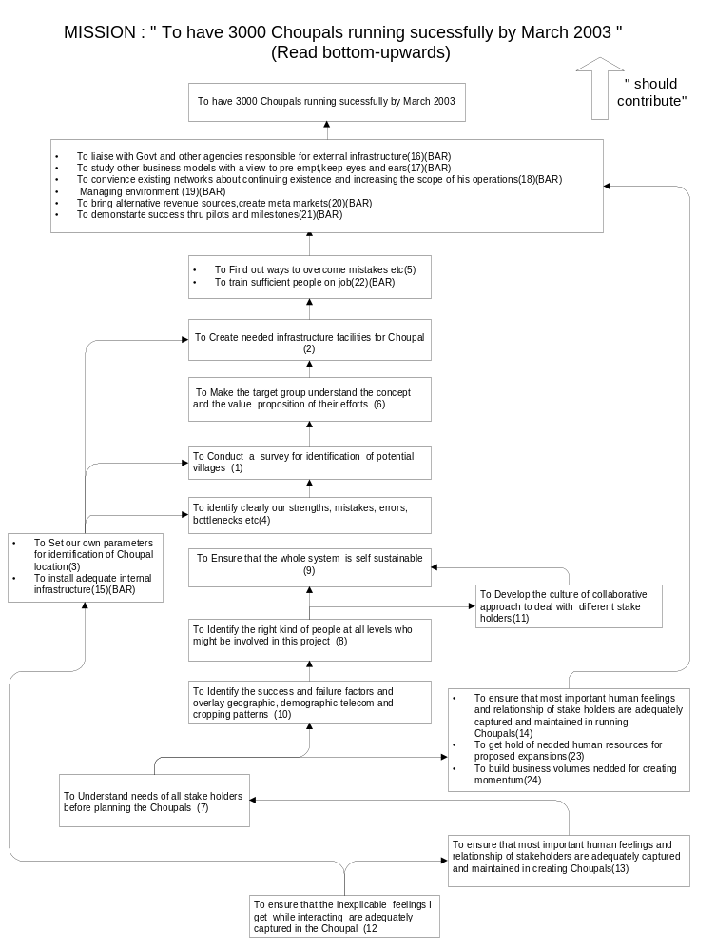

Part of a Field Representation: THINGS TO DO “To have 3000 Choupals running successfully by March 2003”

 | A: TALASH – FEASIBILITY STUDY |  | B: KARYAKARAM – ACTION PLAN |  |  |  | C: SAMANVAY – COLLABORATION
 | - To Conduct a survey for identification of potential villages (1)  - To Set our own parameters for identification of Choupal location (3)  - To Identify the success and failure factors and overlay geographic, demographic telecom and cropping patterns (10) |  | - To Create needed infrastructure facilities for Choupal (2)  - To Understand needs of all stake holders before planning the Choupals (7)  - To liaise with govt and other agencies responsible for external infrastructure (16)  - To study other business models with a view to pre-empt , keep eyes and ears open (17)  - To convince existing network about continuing existence and increasing the scope of his operation (18)  - Managing the environment (19)  - To bring alternative revenue source , create meta markets (20)  - To train sufficient people on job , (22)  - To get hold of needed human resources for proposed expansions (23)  - 24 To build business volumes needed for creating momentum (24) |  |  |  | - To Make the target group understand the concept and the value proposition of their efforts (6)  - To Identify the right kind of people at all levels who might be involved in this project (8)  - To Develop the culture of collaborative approach to deal with different stake holders (11)  - To demonstrate success thru pilots and milestones (21)  - To ensure that most important human feelings and relationship of stakeholders are adequately captured and maintained in creating Choupals (13)  - 14 To ensure that most important human feelings and relationship of stakeholders are adequately captured and maintained in running Choupals (14)
 |  |  |  | SYSTEM TIE LINE
 | D: CHINTAN – EVALUATION  - To identify clearly our strengths, mistakes,errors,bottlenecks etc (4)  - To Find out ways to overcome mistakes etc (5) |  | E : SAKSHAM – SELF SUSTAINABLE  - To Ensure that the whole system is self sustainable (9) |  |  |  | F : SANCHAY – REPOSITORY  - To ensure that the inexplicable feelings I get while interacting are adequately captured in the Choupal (12)

Practical Models developed for Organizations in live OPMS Workshops

